**EXISTING TECHNIQUES**

**4.1 Multilayer Perceptions**

MultiLayer perception (MLP) classifier based on Neural Networks is commonly used to recognize handwritten digits from various sources. Multilayer perceptron contains three different layers namely input layer, output layer and hidden layer. Each layer can has a definite number of nodes also known as neurons and each node of a particular layer is joined to every other node in the other layers . Therefore, it is also known as feed forward network. The number of nodes present in the input layer of the MLP solely depends upon the number of attributes that are there in the dataset. The number of nodes in the output layer ,on the other hand, depends on the number of apparent classes that exist in the dataset. The suitable number of hidden layers or the suitable number of nodes in the hidden layer of the MLP for a specific problem is hard to find out. But in general, the numbers are selected experimentally. In multilayer perceptron, the connection between two nodes has a weight. During training process, the MLP learns the accurate weight adjustment with respect to each connection. For the learning purpose, it makes use of a supervised learning technique which is known as Back propagation algorithm.

**4.2 Support Vector Machine**

SVM or Support Vector Machine is a kind of supervised Machine Learning method that attempts to classify data points by maximizing the margin present among classes in a space of high dimension . SVM depicts examples as points in space mapped due to the examples of the separate classes. After that, new examples are mapped into that same space and predicted to occupy a category based on which side of the gap they fall in . The optimum algorithm is processed through a “training” phase in which training data is acquired to produce an algorithm that is able to distinguish between groups earlier described by the operator (e.g. patients vs. controls), and the “testing” phase in which the algorithm is acquired to blind-predict the group to with which a new perception is associated . It also supplies a very accurate classification performance over the training records and produces enough search space for the accurate presentation of future data parameters. Hence it always makes sure that a series of parameter amalgamations no less than on a sensible subset of the data. In Support Vector Machines, it is better to scale the data everytime; because it will produce improved results.

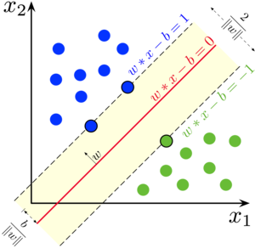

5

**4.3 Random Forest Algorithm**

Random forest is a group of classification trees, triggered from bootstrap samples of the training data, acquiring selection of random features in the tree imitation procedure. The prophecy is made by generating the prophecies of the group by superiority voting for classification. It returns error rate with respect to generalization and is much more potent to noise. Still, unlike most classifiers, Random Forest may also put up with the curse of learning from an intensely unfairly balanced training data set. Since it is built to lower the overall error rate, it tends to focus more on the prophecy efficiency of the majority class, which in turn results in poor accuracy for the minority class in a repeated fashion.

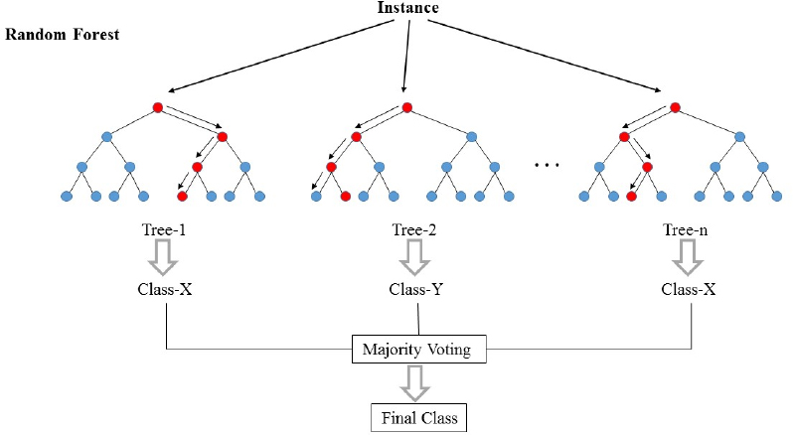

6

**3.4 Naive Bayes Classifier**

The Naive Bayes classifier provides an easy method, showing and learning probabilistic knowledge with clearly defined semantics. It is termed naive because of two main reason. First, it assumes that predictive attributes are conditionally self-dependent given the class. Secondly, it considers that no hidden attributes affect the prediction procedure. It is a probabilistic classifier which mainly depends upon Bayes theorem with various robust and naive independent assumptions. It is one of the numerous best basic text classification techniques with innumerable applications such as personal email sorting, email spam detection, sexually explicit content detection, document categorization, sentiment detection, language detection etc. The naïve design and detailed assumptions that this approach uses does not affect the efficiency of Naive Bayes classifier. Although it is often outshone by various other approaches such Max Entropy, Support Vector Machines, random forests, boosted trees etc, Naive Bayes classifier is very potent and it requires only a small amount of training data. Moreover, the training time in Naive Bayes classifier is much less as compared to other alternative techniques..

